Assignment 7: Implementing the Perceiver AR Architecture
CSC 492/592: Large Language Models

Background

The Perceiver AR Transformer architecture (https://arxiv.org/abs/2202.07765) presents a simple and effective approach to handling long sequence lengths in AutoRegressive language models. The main idea is to divide the input sequence into two parts. The first part is used as a fixed history. The second part is called the latent part and is used to train the model in an autoregressive manner.

In PerceiverAR, the first layer is different from the remaining layers. The query is computed only on the latent part, and the key and values are computed on the entire sequence length. The attention equations governing the PerceiverAR in the first layer were shown in lecture 9. In the first layer, $Q$ only uses the latent representation, while $K$ and $V$ use the full sequence. The remaining layers only operate on the latent representation. As illustrated by the following diagram of the architecture:
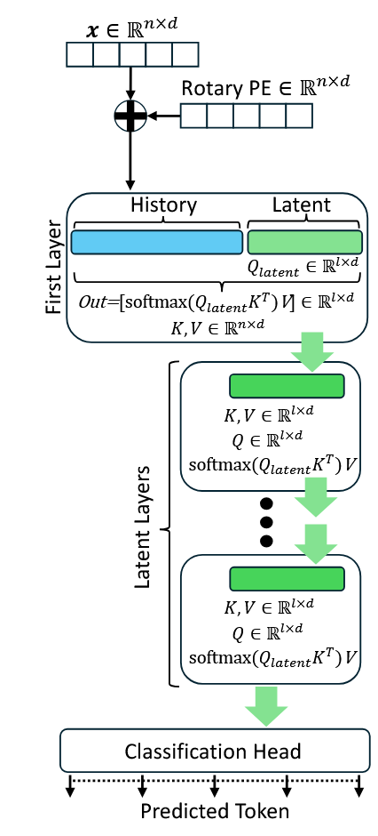

Using our autoregressive training and generation framework that we developed in Assignment #5, we will program the PerceiverAR.

Step by Step Guide

Step 1: Create a PythonApplication called “TransformerPerceiverAR”. Add “checkpoint”, “models”, and “data” folders to the project. Add subfolders of “text8” and “wikitext-103” under the “data” folder. Add existing files related to “wikitext-103” like the previous assignment.

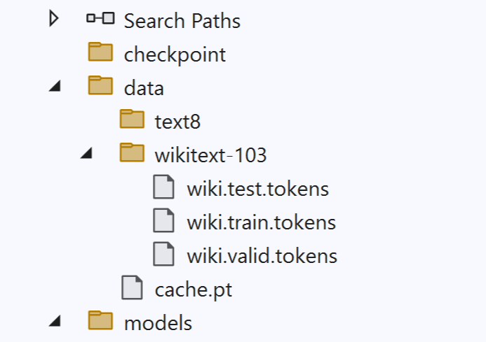

Step 2: Add a file “Utils.py” to the main project folder with the following code in it:

import numpy as np
import torch
from MyNLPDataSet import MyNLPDataSet
from WikitextDataset import WikitextDataset
from torch.utils.data import DataLoader
import gzip
from data_utils import Corpus
from data_utils import get_lm_corpus
import argparse

#following commented functions are for character level modeling----------
def decode_token_char(token): # convert token to character
return str(chr(max(32, token)))

def decode_tokens_char(tokens): # convert sequence of characters to tokens
return ''.join(list(map(decode_token_char, tokens)))
#------------------------------------------------------------------------

def cycle(loader):
while True:
for data in loader:
yield data

def get_loaders_enwiki8_basedon_transformerXL(seq_len, batch_size):
parser = argparse.ArgumentParser(description='PyTorch Transformer Language Model')
parser.add_argument('--data', type=str, default='./enwik8',
help='location of the data corpus')
parser.add_argument('--dataset', type=str, default='enwik8',
choices=['wt103', 'lm1b', 'enwik8', 'text8'],
help='dataset name')
parser.add_argument('--split', type=str, default='train',
choices=['train','all', 'valid', 'test'],
help='which split to evaluate')
parser.add_argument('--batch_size', type=int, default=10,
help='batch size')
parser.add_argument('--tgt_len', type=int, default=5,
help='number of tokens to predict')

args = parser.parse_args()

corpus = get_lm_corpus(args.data, args.dataset)
ntokens = len(corpus.vocab)
print('length of dictionary =',ntokens)

train_dataset = MyNLPDataSet(corpus.train, seq_len)
val_dataset = MyNLPDataSet(corpus.valid, seq_len)
test_dataset = MyNLPDataSet(corpus.test, seq_len)
train_loader = cycle(DataLoader(train_dataset, batch_size = batch_size))
val_loader = cycle(DataLoader(val_dataset, batch_size = batch_size))
test_loader = cycle(DataLoader(test_dataset, batch_size = batch_size))
# yy = next(train_loader)
# tokens = [int(a) for a in corpus.vocab.get_symbols(yy[0])]
# print(decode_tokens_char(tokens))
return train_loader, val_loader, test_loader, val_dataset

def get_loaders_enwiki8(seq_len, batch_size):
# ---------prepare enwik8 data-----------
with gzip.open('./data/enwik8.gz') as file:
data = np.fromstring(file.read(int(95e6)), dtype = np.uint8)
data_train, data_val = map(torch.from_numpy, np.split(data, [int(90e6)]))

train_dataset = MyNLPDataSet(data_train, seq_len)
val_dataset = MyNLPDataSet(data_val, seq_len)
train_loader = cycle(DataLoader(train_dataset, batch_size = batch_size))
val_loader = cycle(DataLoader(val_dataset, batch_size = batch_size))
test_loader = cycle(DataLoader(val_dataset, batch_size = batch_size))
return train_loader, val_loader, test_loader, val_dataset

def get_loaders_text8(seq_len, batch_size):
# ---------prepare enwik8 data-----------
#file_train = open('./data/text8/train.txt', 'r')
file_train = open('./data/text8files/text8.train.txt', 'r')
data_train = torch.from_numpy(np.fromstring(file_train.read(),dtype=np.uint8))
#file_val = open('./data/text8/valid.txt', 'r')
file_val = open('./data/text8files/text8.dev.txt', 'r')
data_val = torch.from_numpy(np.fromstring(file_val.read(),dtype=np.uint8))
#file_test = open('./data/text8/test.txt', 'r')
file_test = open('./data/text8files/text8.test.txt', 'r')
data_test = torch.from_numpy(np.fromstring(file_test.read(),dtype=np.uint8))

train_dataset = MyNLPDataSet(data_train, seq_len)
val_dataset = MyNLPDataSet(data_val, seq_len)
test_dataset = MyNLPDataSet(data_test, seq_len)
train_loader = cycle(DataLoader(train_dataset, batch_size = batch_size))
val_loader = cycle(DataLoader(val_dataset, batch_size = batch_size))
test_loader = cycle(DataLoader(test_dataset, batch_size = batch_size))
return train_loader, val_loader, test_loader, val_dataset

def get_loaders_wikitext_103(tokenizer, seq_len, batch_size):
file_path_train = "data/wikitext-103/wiki.train.tokens"
file_path_valid = "data/wikitext-103/wiki.valid.tokens"
file_path_test = "data/wikitext-103/wiki.test.tokens"
train_dataset = WikitextDataset(tokenizer, file_path_train,"TRAIN", seq_len=seq_len)
val_dataset = WikitextDataset(tokenizer, file_path_valid,"VALID", seq_len=seq_len)
test_dataset = WikitextDataset(tokenizer, file_path_test,"TEST", seq_len=seq_len)
train_loader = cycle(DataLoader(train_dataset, batch_size=batch_size, shuffle=True))
val_loader = cycle(DataLoader(val_dataset, batch_size=batch_size, shuffle=False))
test_loader = cycle(DataLoader(test_dataset, batch_size=batch_size, shuffle=False))
return train_loader, val_loader, test_loader, val_dataset, test_dataset

Step 3: Similarly add the same files from Assignment #5 to the main project folder: “WikitextDataset.py” and “MyNLPDataSet.py”.

Step 4: Add “data_utils.py” Python file to the project:

import os, sys
import glob

from collections import Counter, OrderedDict
import numpy as np
import torch

from vocab import Vocab

class LMOrderedIterator(object):
def __init__(self, data, bsz, bptt, device='cpu', ext_len=None):
"""
data -- LongTensor -- the LongTensor is strictly ordered
"""
self.bsz = bsz
self.bptt = bptt
self.ext_len = ext_len if ext_len is not None else 0

self.device = device

# Work out how cleanly we can divide the dataset into bsz parts.
self.n_step = data.size(0) // bsz

# Trim off any extra elements that wouldn't cleanly fit (remainders).
data = data.narrow(0, 0, self.n_step * bsz)

# Evenly divide the data across the bsz batches.
self.data = data.view(bsz, -1).t().contiguous().to(device)

# Number of mini-batches
self.n_batch = (self.n_step + self.bptt - 1) // self.bptt

def get_batch(self, i, bptt=None):
if bptt is None: bptt = self.bptt
seq_len = min(bptt, self.data.size(0) - 1 - i)

end_idx = i + seq_len
beg_idx = max(0, i - self.ext_len)

data = self.data[beg_idx:end_idx]
target = self.data[i+1:i+1+seq_len]

return data, target, seq_len

def get_fixlen_iter(self, start=0):
for i in range(start, self.data.size(0) - 1, self.bptt):
yield self.get_batch(i)

def get_varlen_iter(self, start=0, std=5, min_len=5, max_deviation=3):
max_len = self.bptt + max_deviation * std
i = start
while True:
bptt = self.bptt if np.random.random() < 0.95 else self.bptt / 2.
bptt = min(max_len, max(min_len, int(np.random.normal(bptt, std))))
data, target, seq_len = self.get_batch(i, bptt)
i += seq_len
yield data, target, seq_len
if i >= self.data.size(0) - 2:
break

def __iter__(self):
return self.get_fixlen_iter()

class LMShuffledIterator(object):
def __init__(self, data, bsz, bptt, device='cpu', ext_len=None, shuffle=False):
"""
data -- list[LongTensor] -- there is no order among the LongTensors
"""
self.data = data
self.bsz = bsz
self.bptt = bptt
self.ext_len = ext_len if ext_len is not None else 0

self.device = device
self.shuffle = shuffle

def get_sent_stream(self):
# index iterator
epoch_indices = np.random.permutation(len(self.data)) if self.shuffle \
else np.array(range(len(self.data)))

# sentence iterator
for idx in epoch_indices:
yield self.data[idx]

def stream_iterator(self, sent_stream):
# streams for each data in the batch
streams = [None] * self.bsz

data = torch.LongTensor(self.bptt, self.bsz)
target = torch.LongTensor(self.bptt, self.bsz)

n_retain = 0

while True:
# data : [n_retain+bptt x bsz]
# target : [bptt x bsz]
data[n_retain:].fill_(-1)
target.fill_(-1)
valid_batch = True

for i in range(self.bsz):
n_filled = 0
try:
while n_filled < self.bptt:
if streams[i] is None or len(streams[i]) <= 1:
streams[i] = next(sent_stream)
# number of new tokens to fill in
n_new = min(len(streams[i]) - 1, self.bptt - n_filled)
# first n_retain tokens are retained from last batch
data[n_retain+n_filled:n_retain+n_filled+n_new, i] = \
streams[i][:n_new]
target[n_filled:n_filled+n_new, i] = \
streams[i][1:n_new+1]
streams[i] = streams[i][n_new:]
n_filled += n_new
except StopIteration:
valid_batch = False
break

if not valid_batch:
return

data = data.to(self.device)
target = target.to(self.device)
yield data, target, self.bptt

n_retain = min(data.size(0), self.ext_len)
if n_retain > 0:
data[:n_retain] = data[-n_retain:]
data.resize_(n_retain + self.bptt, data.size(1))

def __iter__(self):
# sent_stream is an iterator
sent_stream = self.get_sent_stream()

for batch in self.stream_iterator(sent_stream):
yield batch

class LMMultiFileIterator(LMShuffledIterator):
def __init__(self, paths, vocab, bsz, bptt, device='cpu', ext_len=None,
shuffle=False):

self.paths = paths
self.vocab = vocab

self.bsz = bsz
self.bptt = bptt
self.ext_len = ext_len if ext_len is not None else 0

self.device = device
self.shuffle = shuffle

def get_sent_stream(self, path):
sents = self.vocab.encode_file(path, add_double_eos=True)
if self.shuffle:
np.random.shuffle(sents)
sent_stream = iter(sents)

return sent_stream

def __iter__(self):
if self.shuffle:
np.random.shuffle(self.paths)

for path in self.paths:
# sent_stream is an iterator
sent_stream = self.get_sent_stream(path)
for batch in self.stream_iterator(sent_stream):
yield batch

class Corpus(object):
def __init__(self, path, dataset, *args, **kwargs):
self.dataset = dataset
self.vocab = Vocab(*args, **kwargs)

if self.dataset in ['ptb', 'wt2', 'enwik8', 'text8']:
self.vocab.count_file(os.path.join(path, 'train.txt'))
self.vocab.count_file(os.path.join(path, 'valid.txt'))
self.vocab.count_file(os.path.join(path, 'test.txt'))
elif self.dataset == 'wt103':
self.vocab.count_file(os.path.join(path, 'train.txt'))
elif self.dataset == 'lm1b':
train_path_pattern = os.path.join(
path, '1-billion-word-language-modeling-benchmark-r13output',
'training-monolingual.tokenized.shuffled', 'news.en-*')
train_paths = glob.glob(train_path_pattern)
# the vocab will load from file when build_vocab() is called

self.vocab.build_vocab()

if self.dataset in ['ptb', 'wt2', 'wt103']:
self.train = self.vocab.encode_file(
os.path.join(path, 'train.txt'), ordered=True)
self.valid = self.vocab.encode_file(
os.path.join(path, 'valid.txt'), ordered=True)
self.test = self.vocab.encode_file(
os.path.join(path, 'test.txt'), ordered=True)
elif self.dataset in ['enwik8', 'text8']:
self.train = self.vocab.encode_file(
os.path.join(path, 'train.txt'), ordered=True, add_eos=False)
self.valid = self.vocab.encode_file(
os.path.join(path, 'valid.txt'), ordered=True, add_eos=False)
self.test = self.vocab.encode_file(
os.path.join(path, 'test.txt'), ordered=True, add_eos=False)
elif self.dataset == 'lm1b':
self.train = train_paths
self.valid = self.vocab.encode_file(
os.path.join(path, 'valid.txt'), ordered=False, add_double_eos=True)
self.test = self.vocab.encode_file(
os.path.join(path, 'test.txt'), ordered=False, add_double_eos=True)

def get_iterator(self, split, *args, **kwargs):
if split == 'train':
if self.dataset in ['ptb', 'wt2', 'wt103', 'enwik8', 'text8']:
data_iter = LMOrderedIterator(self.train, *args, **kwargs)
elif self.dataset == 'lm1b':
kwargs['shuffle'] = True
data_iter = LMMultiFileIterator(self.train, self.vocab, *args, **kwargs)
elif split in ['valid', 'test']:
data = self.valid if split == 'valid' else self.test
if self.dataset in ['ptb', 'wt2', 'wt103', 'enwik8', 'text8']:
data_iter = LMOrderedIterator(data, *args, **kwargs)
elif self.dataset == 'lm1b':
data_iter = LMShuffledIterator(data, *args, **kwargs)

return data_iter

def get_lm_corpus(datadir, dataset):
fn = os.path.join(datadir, 'cache.pt')
fn = "D:/DeepLearning2/BPCOnTransformer/enwik8/cache.pt"
if os.path.exists(fn):
print('Loading cached dataset...')
corpus = torch.load(fn)
else:
print('Producing dataset {}...'.format(dataset))
kwargs = {}
if dataset in ['wt103', 'wt2']:
kwargs['special'] = ['<eos>']
kwargs['lower_case'] = False
elif dataset == 'ptb':
kwargs['special'] = ['<eos>']
kwargs['lower_case'] = True
elif dataset == 'lm1b':
kwargs['special'] = []
kwargs['lower_case'] = False
kwargs['vocab_file'] = os.path.join(datadir, '1b_word_vocab.txt')
elif dataset in ['enwik8', 'text8']:
pass

corpus = Corpus(datadir, dataset, **kwargs)
torch.save(corpus, fn)

return corpus

Step 5: Add “vocab.py” Python file to the project:

import os
from collections import Counter, OrderedDict

import torch

class Vocab(object):
def __init__(self, special=[], min_freq=0, max_size=None, lower_case=True,
delimiter=None, vocab_file=None):
self.counter = Counter()
self.special = special
self.min_freq = min_freq
self.max_size = max_size
self.lower_case = lower_case
self.delimiter = delimiter
self.vocab_file = vocab_file

def tokenize(self, line, add_eos=False, add_double_eos=False):
line = line.strip()
# convert to lower case
if self.lower_case:
line = line.lower()

# empty delimiter '' will evaluate False
if self.delimiter == '':
symbols = line
else:
symbols = line.split(self.delimiter)

if add_double_eos: # lm1b
return ['<S>'] + symbols + ['<S>']
elif add_eos:
return symbols + ['<eos>']
else:
return symbols

def count_file(self, path, verbose=False, add_eos=False):
if verbose: print('counting file {} ...'.format(path))
assert os.path.exists(path)

sents = []
with open(path, 'r', encoding='utf-8') as f:
for idx, line in enumerate(f):
if verbose and idx > 0 and idx % 500000 == 0:
print(' line {}'.format(idx))
symbols = self.tokenize(line, add_eos=add_eos)
self.counter.update(symbols)
sents.append(symbols)

return sents

def count_sents(self, sents, verbose=False):
"""
sents : a list of sentences, each a list of tokenized symbols
"""
if verbose: print('counting {} sents ...'.format(len(sents)))
for idx, symbols in enumerate(sents):
if verbose and idx > 0 and idx % 500000 == 0:
print(' line {}'.format(idx))
self.counter.update(symbols)

def _build_from_file(self, vocab_file):
self.idx2sym = []
self.sym2idx = OrderedDict()

with open(vocab_file, 'r', encoding='utf-8') as f:
for line in f:
symb = line.strip().split()[0]
self.add_symbol(symb)
self.unk_idx = self.sym2idx['<UNK>']

def build_vocab(self):
if self.vocab_file:
print('building vocab from {}'.format(self.vocab_file))
self._build_from_file(self.vocab_file)
print('final vocab size {}'.format(len(self)))
else:
print('building vocab with min_freq={}, max_size={}'.format(
self.min_freq, self.max_size))
self.idx2sym = []
self.sym2idx = OrderedDict()

for sym in self.special:
self.add_special(sym)

for sym, cnt in self.counter.most_common(self.max_size):
if cnt < self.min_freq: break
self.add_symbol(sym)

print('final vocab size {} from {} unique tokens'.format(
len(self), len(self.counter)))

def encode_file(self, path, ordered=False, verbose=False, add_eos=True,
add_double_eos=False):
if verbose: print('encoding file {} ...'.format(path))
assert os.path.exists(path)
encoded = []
with open(path, 'r', encoding='utf-8') as f:
for idx, line in enumerate(f):
if verbose and idx > 0 and idx % 500000 == 0:
print(' line {}'.format(idx))
symbols = self.tokenize(line, add_eos=add_eos,
add_double_eos=add_double_eos)
encoded.append(self.convert_to_tensor(symbols))

if ordered:
encoded = torch.cat(encoded)

return encoded

def encode_sents(self, sents, ordered=False, verbose=False):
if verbose: print('encoding {} sents ...'.format(len(sents)))
encoded = []
for idx, symbols in enumerate(sents):
if verbose and idx > 0 and idx % 500000 == 0:
print(' line {}'.format(idx))
encoded.append(self.convert_to_tensor(symbols))

if ordered:
encoded = torch.cat(encoded)

return encoded

def add_special(self, sym):
if sym not in self.sym2idx:
self.idx2sym.append(sym)
self.sym2idx[sym] = len(self.idx2sym) - 1
setattr(self, '{}_idx'.format(sym.strip('<>')), self.sym2idx[sym])

def add_symbol(self, sym):
if sym not in self.sym2idx:
self.idx2sym.append(sym)
self.sym2idx[sym] = len(self.idx2sym) - 1

def get_sym(self, idx):
assert 0 <= idx < len(self), 'Index {} out of range'.format(idx)
return self.idx2sym[idx]

def get_idx(self, sym):
if sym in self.sym2idx:
return self.sym2idx[sym]
else:
# print('encounter unk {}'.format(sym))
assert '<eos>' not in sym
assert hasattr(self, 'unk_idx')
return self.sym2idx.get(sym, self.unk_idx)

def get_symbols(self, indices):
return [self.get_sym(idx) for idx in indices]

def get_indices(self, symbols):
return [self.get_idx(sym) for sym in symbols]

def convert_to_tensor(self, symbols):
return torch.LongTensor(self.get_indices(symbols))

def convert_to_sent(self, indices, exclude=None):
if exclude is None:
return ' '.join([self.get_sym(idx) for idx in indices])
else:
return ' '.join([self.get_sym(idx) for idx in indices if idx not in exclude])

def __len__(self):
return len(self.idx2sym)

Step 6: Add “Rotary_Embedding_torch.py” Python file to the project:

from inspect import isfunction
from math import pi, log
import torch
from torch import nn, einsum
from einops import rearrange, repeat

# helper functions

def exists(val):
return val is not None

def broadcat(tensors, dim = -1):
num_tensors = len(tensors)
shape_lens = set(list(map(lambda t: len(t.shape), tensors)))
assert len(shape_lens) == 1, 'tensors must all have the same number of dimensions'
shape_len = list(shape_lens)[0]

dim = (dim + shape_len) if dim < 0 else dim
dims = list(zip(*map(lambda t: list(t.shape), tensors)))

expandable_dims = [(i, val) for i, val in enumerate(dims) if i != dim]
assert all([*map(lambda t: len(set(t[1])) <= 2, expandable_dims)]), 'invalid dimensions for broadcastable concatentation'
max_dims = list(map(lambda t: (t[0], max(t[1])), expandable_dims))
expanded_dims = list(map(lambda t: (t[0], (t[1],) * num_tensors), max_dims))
expanded_dims.insert(dim, (dim, dims[dim]))
expandable_shapes = list(zip(*map(lambda t: t[1], expanded_dims)))
tensors = list(map(lambda t: t[0].expand(*t[1]), zip(tensors, expandable_shapes)))
return torch.cat(tensors, dim = dim)

# rotary embedding helper functions

def rotate_half(x):
x = rearrange(x, '... (d r) -> ... d r', r = 2)
x1, x2 = x.unbind(dim = -1)
x = torch.stack((-x2, x1), dim = -1)
return rearrange(x, '... d r -> ... (d r)')

def apply_rotary_emb(freqs, t, start_index = 0):
freqs = freqs.to(t)
rot_dim = freqs.shape[-1]
end_index = start_index + rot_dim
assert rot_dim <= t.shape[-1], f'feature dimension {t.shape[-1]} is not of sufficient size to rotate in all the positions {rot_dim}'
t_left, t, t_right = t[..., :start_index], t[..., start_index:end_index], t[..., end_index:]
t = (t * freqs.cos()) + (rotate_half(t) * freqs.sin())
return torch.cat((t_left, t, t_right), dim = -1)

# learned rotation helpers
def apply_learned_rotations(rotations, t, start_index = 0, freq_ranges = None):
if exists(freq_ranges):
rotations = einsum('..., f -> ... f', rotations, freq_ranges)
rotations = rearrange(rotations, '... r f -> ... (r f)')

rotations = repeat(rotations, '... n -> ... (n r)', r = 2)
return apply_rotary_emb(rotations, t, start_index = start_index)
# classes
class RotaryEmbedding(nn.Module):
def __init__(
self,
dim,
custom_freqs = None,
freqs_for = 'lang',
theta = 10000,
max_freq = 10,
num_freqs = 1,
learned_freq = False
):
super().__init__()
if exists(custom_freqs):
freqs = custom_freqs
elif freqs_for == 'lang':
freqs = 1. / (theta ** (torch.arange(0, dim, 2)[:(dim // 2)].float() / dim))
elif freqs_for == 'pixel':
freqs = torch.linspace(1., max_freq / 2, dim // 2) * pi
elif freqs_for == 'constant':
freqs = torch.ones(num_freqs).float()
else:
raise ValueError(f'unknown modality {freqs_for}')

self.cache = dict()

if learned_freq:
self.freqs = nn.Parameter(freqs)
else:
self.register_buffer('freqs', freqs)

def rotate_queries_or_keys(self, t, seq_dim = -2):
device = t.device
seq_len = t.shape[seq_dim]
freqs = self.forward(lambda: torch.arange(seq_len, device = device), cache_key = seq_len)
return apply_rotary_emb(freqs, t)

def forward(self, t, cache_key = None):
if exists(cache_key) and cache_key in self.cache:
return self.cache[cache_key]

if isfunction(t):
t = t()

freqs = self.freqs

freqs = torch.einsum('..., f -> ... f', t.type(freqs.dtype), freqs)
freqs = repeat(freqs, '... n -> ... (n r)', r = 2)

if exists(cache_key):
self.cache[cache_key] = freqs

return freqs

Step 7: Add a file called “PerceiverAR.py” to the models folder with the following code in it.

from math import gcd, ceil
import functools

import torch
from torch import nn, einsum
import torch.nn.functional as F

from Rotary_Embedding_torch import RotaryEmbedding, apply_rotary_emb

from einops import rearrange, repeat
import numpy as np

# -----------helper functions---------------
def exists(val):
return val is not None

def default(val, d):
return val if exists(val) else d

class PreNorm(nn.Module):
def __init__(self, dim, fn):
super().__init__()
self.fn = fn
self.norm = nn.LayerNorm(dim)

def forward(self, x, **kwargs):
x = self.norm(x)
return self.fn(x, **kwargs)

class FeedForward(nn.Module):
def __init__(self, dim, mult = 4, dropout = 0.):
super().__init__()
self.net = nn.Sequential(
nn.Linear(dim, dim * mult),
nn.GELU(),
nn.Dropout(dropout),
nn.Linear(dim * mult, dim)
)

def forward(self, x):
return self.net(x)

class PerceiverARAttention(nn.Module):
def __init__(
self,
*,
dim = 512, # embedding size
heads = 8,
causal = True,
sequence_len = 1024,
latent_len = 256, # history = sequence length - latent
pos_emb = None,
dropout = 0.,
layer_num = 0
):
super().__init__()
self.sequence_len = sequence_len
self.latent_len = latent_len
self.history_len = self.sequence_len - self.latent_len
assert (self.history_len + latent_len == sequence_len), 'history_length plus latent should be equal to sequence length'
self.layer_num = layer_num # for PerceiverAR, first layer is different
self.dim_head = dim//heads # 512/8 = 64
self.scale = self.dim_head ** -0.5 # 1/8

self.heads = heads
self.causal = causal

self.norm = nn.LayerNorm(self.dim_head) # (64)

self.pos_emb = default(pos_emb, RotaryEmbedding(self.dim_head))
self.attn_dropout = nn.Dropout(dropout)

self.to_q = nn.Linear(dim, dim, bias = False) # e.g.,(512, 512)
self.to_kv = nn.Linear(dim, dim, bias = False) # e.g., (512, 512)
self.w_out = nn.Linear(dim, dim) # e.g., (512, 512)

def forward(self, x, mask = None): # e.g., x has shape of (4,1024,512)
b, n, *_, heads, device, causal = *x.shape, self.heads, x.device, self.causal,
# e.g., b = 4, n = 1024, *, h = 8, device, causal

mask_value = -torch.finfo(x.dtype).max # negative inf.

# get queries, keys, values
qkv = (self.to_q(x), self.to_kv(x)) # e.g., (4, 1024, 512)
total_len = x.shape[-2] # 1024
# get sequence range, for calculating mask
seq_range = torch.arange(total_len, device = device)

# split heads
q, kv = map(lambda t: rearrange(t, 'b n (h d) -> (b h) n d', h = heads), qkv) # b = 4, n = 1024, h = 8, d = 64;
# e.g., q, kv = [32, 1024, 64]
if self.layer_num == 0:
q = q[:,self.history_len:,:]

# rotary embedding
if exists(self.pos_emb):
rotary_emb = self.pos_emb(seq_range, cache_key = total_len) # (1024, 64)
rotary_emb = rearrange(rotary_emb, 'n d -> () n d') # (1,1024,64)
if self.layer_num == 0:
q = apply_rotary_emb(rotary_emb[:,self.history_len:,:],q)
kv = apply_rotary_emb(rotary_emb,kv)

# scale queries
q = q * self.scale # (32,1024,64) - each head

kv_norm = self.norm(kv)
attn = einsum('b i d, b j d -> b i j', q, kv_norm)
# [32, 256, 1024]; b = 32, (attention of latent_lenxsequence_len e.g., 256x1024)

m_size = attn.shape[-2] # size of mask

if exists(mask): # called when generate triggers
mask = rearrange(mask, 'b n -> b () n') # [8, 8, 1, 256]
attn.masked_fill_(~mask, mask_value)

if self.causal:
if self.layer_num == 0: # last q part of attention is masked in first layer
causal_mask = torch.ones(m_size, m_size, device = device).triu_(1).bool()
attn[:,:,self.history_len:].masked_fill_(causal_mask, mask_value)
else:
causal_mask = torch.ones(m_size, m_size, device = device).triu_(1).bool()
attn.masked_fill_(causal_mask, mask_value)

# final attention
attn = attn.softmax(dim = -1)
attn = self.attn_dropout(attn)

# aggregate values (same as keys, since tied) and project out
out = einsum('b i j, b j d -> b i d', attn, kv_norm)
out = rearrange(out, '(b h) n d -> b (n) (h d)', h = heads)
#out = out[:, :n]
return self.w_out(out)

class PerceiverARTransformer(nn.Module):
def __init__(
self,
*,
num_tokens, # for output size determination
dim, # embedding
latent_len,
num_layers, # number of layers
heads = 8,
sequence_len,
causal = True,
ff_mult = 4, # expand feedforward by 4 times then reduce back to embedding size
ff_dropout = 0.,
attn_dropout = 0.
):
super().__init__()
self.sequence_len = sequence_len
self.latent_len = latent_len
self.token_emb = nn.Embedding(num_tokens, dim)
self.dim_head = dim//heads
pos_emb = RotaryEmbedding(self.dim_head)

self.layers = nn.ModuleList([])
for i in range(num_layers):
self.layers.append(nn.ModuleList([
PreNorm(dim, PerceiverARAttention(dim = dim, heads = heads, sequence_len = sequence_len, latent_len = latent_len,causal = causal,layer_num=i, pos_emb = pos_emb, dropout = attn_dropout)),
PreNorm(dim, FeedForward(dim = dim, mult = ff_mult, dropout = ff_dropout))
]))

self.to_logits = nn.Sequential(
nn.LayerNorm(dim),
nn.Linear(dim, num_tokens)
)

def forward(self, x, mask = None):
x = self.token_emb(x)
for attn, ff in self.layers:
if attn.fn.layer_num == 0: # layer_num
x = attn(x, mask = mask) + x[:,-self.latent_len:,:]
else:
x = attn(x, mask = mask) + x
x = ff(x) + x # [4, 1024, 512]
return self.to_logits(x)

Step 8: Add a file called “AutoRegressiveWrapper.py” to the main project folder with the following code in it.

import torch
from torch import nn
import torch.nn.functional as F

# ---------top k from logits, logits = layer before softmax
def top_k(logits, thres = 0.9):
k = int((1 - thres) * logits.shape[-1]) # top 25
val, ind = torch.topk(logits, k)
probs = torch.full_like(logits, float('-inf')) # fill probs=[1,256] with -inf
probs.scatter_(1, ind, val) # 1=dim, it will fill probs with val at ind location
return probs # i.e., top 25 locations will have values, rest -inf

class AutoRegressiveWrapper(nn.Module):
def __init__(self, net, latent_len, pad_value = 0):
super().__init__()
self.pad_value = pad_value
self.model = net
self.max_seq_len = net.sequence_len
self.latent_len = latent_len

@torch.no_grad()
def generate(self, start_tokens, seq_len, eos_token = None, temperature = 1., filter_thres = 0.9):
self.model.eval()
device = start_tokens.device # start tokens is the seed set of characters
num_dims = len(start_tokens.shape) # 1, e.g., start_tokens = 1024

if num_dims == 1:
start_tokens = start_tokens[None, :] # 1024 --> (1, 1024); [None, :] is an alias for np.newaxis, it will add one more dimension

b, t = start_tokens.shape # b=1, e.g., t=1024. In generation, batch=1
prev_out = start_tokens # e.g., [1x1024]
for i in range(seq_len): # seq_len = e.g., 1024
x = prev_out[:, -self.max_seq_len:] # x=(1, 1024); max_seq_len = 1024
#self.model.set_causal(False) - causes generated output to be not proper
logits = self.model(x)[:, -1, :] # x = [1x1024], logits = [1x256]
#print('in gen..',i)
filtered_logits = top_k(logits, thres = filter_thres) # filtered_logits = (1x256)
# top 10% logits will be kept, others changed to -inf.
probs = F.softmax(filtered_logits / temperature, dim=-1)
predicted_char_token = torch.multinomial(probs, 1) # (1x1)
out = torch.cat((prev_out, predicted_char_token), dim=-1) # (1 x 1025)
prev_out = out
if eos_token is not None and (predicted_char_token == eos_token).all():
break

out = out[:, t:] # generated output sequence after the start sequence, e.g., (1x512)
if num_dims == 1:
out = out.squeeze(0)
#self.model.set_causal(True) - causes generated output to be not proper
return out

def forward(self, x):
#assert(x.shape[-1] == 1025),'seq length should be 1024'
xi = x[:, :-1] # x is input of size seq_len+1, :-1 will make it seq_le
xo = x[:, -self.latent_len:] # expected output in training is shifted one to the left
out = self.model(xi)
logits_reorg = out.view(-1, out.size(-1))
targets_reorg = xo.reshape(-1)
loss = F.cross_entropy(logits_reorg, targets_reorg, ignore_index=-1)
return loss

Step 9: Type the following code in the main file (TransformerPerceiverAR.py):

import random
from tkinter import LAST
import tqdm
import numpy as np

import torch
import torch.optim as optim
from AutoRegressiveWrapper import AutoRegressiveWrapper
from PerceiverAR import PerceiverARTransformer
import Utils
import sys
import math
import os
from transformers import AutoTokenizer # pip install transformers
from data_utils import Corpus

# ---------------------------developed by AM-----------------------------
# Acknowledgement: some parts of code are adapted from Andrej Karpathy and Phil Wang
#-------------------------------------------------------------------------

# ------Architecture constants------------
DO_WORD_LEVEL_MODELING = True # set to false for character level, true for word
NUM_BATCHES = 200000 # int(2e6)
BATCH_SIZE = 4
GRADIENT_ACCUMULATE_EVERY = 2
LEARNING_RATE = 2e-4 # 3e-4 first 100000
VALIDATE_EVERY = 10000
GENERATE_EVERY = 10000
GENERATE_LENGTH = 256
SEQ_LENGTH = 1024 # was 1024
RESUME_TRAINING = False # set to false to start training from beginning
LAST_BEST_PERPLEXITY = 999#21.76

EMBEDDING_SIZE = 512
NUM_HEADS = 8
NUM_LAYERS = 8
LATENT_LEN = 256 # last part of input that Q uses in PerceiverAR
#---------------------------
# 100000 iterations, perp = 31.60

tokenizer_word = AutoTokenizer.from_pretrained("bert-base-cased",truncation=True, max_length=512) # for word level modeling

#following functions are for character level modeling----------
def decode_token_char(token): # convert token to character
return str(chr(max(32, token)))

def decode_tokens_char(tokens): # convert sequence of characters to tokens
return ''.join(list(map(decode_token_char, tokens)))
#------------------------------------------------------------------------

def decode_tokens_word(tokens): # convert token to word - for word level modeling
return tokenizer_word.decode(tokens)

def count_parameters(model): # count number of trainable parameters in the model
return sum(p.numel() for p in model.parameters() if p.requires_grad)

def configure_optimizers(mymodel):
"""
We are separating out all parameters of the model into two buckets: those that will experience
weight decay for regularization and those that won't (biases, and layernorm/embedding weights).
Retur the PyTorch optimizer object.
"""

# separate out parameters that will experience regularizing weight decay
# and those that will not
decay = set()
no_decay = set()
whitelist_weight_modules = (torch.nn.Linear, )
blacklist_weight_modules = (torch.nn.LayerNorm, torch.nn.Embedding)
for mn, m in mymodel.named_modules():
for pn, p in m.named_parameters():
fpn = '%s.%s' % (mn, pn) if mn else pn # full param name
# because named_modules and named_parameters are recursive
# we will see the same tensors p many many times. but doing it this way
# allows us to know which parent module any tensor p belongs to...
if pn.endswith('bias'):
# all biases will not be decayed
no_decay.add(fpn)
elif pn.endswith('weight') and isinstance(m, whitelist_weight_modules):
# weights of whitelist modules will be weight decayed
decay.add(fpn)
elif pn.endswith('weight') and isinstance(m, blacklist_weight_modules):
# weights of blacklist modules will NOT be weight decayed
no_decay.add(fpn)

# validate that we considered every parameter
param_dict = {pn: p for pn, p in mymodel.named_parameters()}
inter_params = decay & no_decay
union_params = decay | no_decay
assert len(inter_params) == 0, "parameters %s made it into both decay/no_decay sets!" % (str(inter_params), )
assert len(param_dict.keys() - union_params) == 0, "parameters %s were not separated into either decay/no_decay set!" \
% (str(param_dict.keys() - union_params), )

# create the pytorch optimizer object
optim_groups = [
{"params": [param_dict[pn] for pn in sorted(list(decay))], "weight_decay": 0.1},
{"params": [param_dict[pn] for pn in sorted(list(no_decay))], "weight_decay": 0.0},
]
optimizer = torch.optim.AdamW(optim_groups, lr=LEARNING_RATE, betas=(0.9,0.95))
return optimizer

def compute_perplexity_huggingface(model,test_set,device,max_len=SEQ_LENGTH):
global LAST_BEST_PERPLEXITY
stride = 512
encodings = test_set.data
encodings = encodings.view(1,encodings.size(0)*encodings.size(1))
seq_len = encodings.size(1)
nlls = []
prev_end_loc = 0
count = 0
for begin_loc in tqdm.tqdm(range(0, seq_len, stride)):
end_loc = min(begin_loc + max_len+1, seq_len+1)
if (end_loc - begin_loc) < (max_len+1):
continue
trg_len = end_loc - prev_end_loc # may be different from stride on last loop
input_ids = encodings[:, begin_loc:end_loc].to(device)
if input_ids.shape[-1] < 1025:
continue
target_ids = input_ids.clone()
target_ids[:, :-trg_len] = -100
count = count + 1
#if (count == 50):
# break
with torch.no_grad():
#outputs = model(input_ids, labels=target_ids) # from hugging face
loss = model(input_ids)
# loss is calculated using CrossEntropyLoss which averages over valid labels
# N.B. the model only calculates loss over trg_len - 1 labels, because it internally shifts the labels
# to the left by 1.
#neg_log_likelihood = outputs.loss # from hugging face

#nlls.append(neg_log_likelihood) # from hugging face
nlls.append(loss)

prev_end_loc = end_loc
if end_loc == seq_len:
break

ppl = torch.exp(torch.stack(nlls).mean())
best_found = False
if LAST_BEST_PERPLEXITY == 999:
LAST_BEST_PERPLEXITY = ppl
else:
if ppl < LAST_BEST_PERPLEXITY:
LAST_BEST_PERPLEXITY = ppl
best_found = True
# save the best model

print("-----------Perplexity------------- = ", ppl, "----loss=",torch.stack(nlls).mean())
return best_found

def save_model(model, i, optim, fname):
# ---------save the latest model---------
print("----------saving model-----------------")
checkpoint_data = {
'epoch': i,
'state_dict': model.state_dict(),
'optimizer': optim.state_dict()
}
ckpt_path = os.path.join("checkpoint/" + fname) #transAM_WK_model_best.pt")
torch.save(checkpoint_data, ckpt_path)
# revert model to training mode
model.train()

def f1():
print(LAST_BEST_PERPLEXITY)

def main():
#f1()
#prep_text8.prepare_text8() # prepare text8 data

#NUM_TOKENS = 256 # for character level modeling
NUM_TOKENS = 204 # based on transformer XL code for enwik8
if DO_WORD_LEVEL_MODELING == True:
NUM_TOKENS = 28996 # bert-base_cased for wikitext-103
dim_head = int(EMBEDDING_SIZE/NUM_HEADS)
longshort_model = PerceiverARTransformer(
dim = EMBEDDING_SIZE, # embedding size - orig 512
#num_tokens = 28996, # for bert-base_cased for wikitext-103,
num_tokens = NUM_TOKENS,
num_layers = NUM_LAYERS,
heads = NUM_HEADS, # orig 8
sequence_len = SEQ_LENGTH,
latent_len = LATENT_LEN
).cuda()

model = AutoRegressiveWrapper(longshort_model, latent_len=LATENT_LEN)
model.cuda()
pcount = count_parameters(model)
print("count of parameters in the model = ", pcount/1e6, " million")

if DO_WORD_LEVEL_MODELING == True:
train_loader, val_loader, test_loader, val_dataset, test_dataset = Utils.get_loaders_wikitext_103(tokenizer_word, SEQ_LENGTH, BATCH_SIZE)
else: # char level modeling
# train_loader, val_loader, test_loader, val_dataset = Utils.get_loaders_enwiki8(SEQ_LENGTH, BATCH_SIZE)
train_loader, val_loader, test_loader, val_dataset = Utils.get_loaders_enwiki8_basedon_transformerXL(SEQ_LENGTH, BATCH_SIZE)
#train_loader, val_loader, test_loader, val_dataset = Utils.get_loaders_text8(SEQ_LENGTH, BATCH_SIZE)

#optim = torch.optim.Adam(model.parameters(), lr = LEARNING_RATE) # optimizer
optim = configure_optimizers(model)

# --------training---------
if RESUME_TRAINING == False:
start = 0
else:
#checkpoint_data = torch.load('checkpoint/transAM_WK_model_baseBPC_1_26.pt')
checkpoint_data = torch.load('checkpoint/transAM_WK_model.pt')
model.load_state_dict(checkpoint_data['state_dict'])
optim.load_state_dict(checkpoint_data['optimizer'])
for param_group in optim.param_groups: # if lr needs to be changed
param_group['lr'] = LEARNING_RATE
start = checkpoint_data['epoch']

for i in tqdm.tqdm(range(start,NUM_BATCHES), mininterval = 10., desc = 'training'):
model.train()
total_loss = 0
for __ in range(GRADIENT_ACCUMULATE_EVERY):
loss = model(next(train_loader))
loss.backward()
if (i%100 == 0):
print(f'training loss: {loss.item()} -- iteration = {i}')

torch.nn.utils.clip_grad_norm_(model.parameters(), 1.0)
optim.step()
optim.zero_grad()

if (i% VALIDATE_EVERY == 0) and (DO_WORD_LEVEL_MODELING == True):
ret = compute_perplexity_huggingface(model,test_dataset,'cuda')
if ret == True: # save best model
print('-------------saving best model------------')
save_model(model,i,optim,"transAM_2048_base_PAR_model_best.pt") # save best model

if ((i+0) % VALIDATE_EVERY == 0) and (DO_WORD_LEVEL_MODELING == False):
model.eval()
total_len2 = 0
total_loss2 = 0
val_count = 50 # 1000 -number of validations to compute average BPC
with torch.no_grad():
for v in range(0,val_count):
zz = next(test_loader)
loss = model(next(test_loader))
total_loss += loss.item()
loss_m = loss.mean()
total_loss2 += SEQ_LENGTH * loss_m.item() #loss.float().item() #seq_len
total_len2 += SEQ_LENGTH
print(f'----------validation loss: {total_loss/val_count}')
print(f'Perplexity : {math.exp(total_loss/val_count)}, BPC: {total_loss/val_count*np.log2(2.7173)}')
bpc2 = (total_loss2/total_len2)/math.log(2)
print("BPC 2 = ", bpc2)
total_loss = 0

if (i+1) % GENERATE_EVERY == 0:
model.eval()
inp = random.choice(val_dataset)[:-1]
if DO_WORD_LEVEL_MODELING == True:
input_start_sequence = decode_tokens_word(inp)
else:
input_start_sequence = decode_tokens_char(inp)
print("----------start input------------------")
print(f'%s \n\n', (input_start_sequence))
print("----------end of start input-----------")
sample = model.generate(inp, GENERATE_LENGTH)
if DO_WORD_LEVEL_MODELING == True:
output_str = decode_tokens_word(sample)
else:
output_str = decode_tokens_char(sample)
print("----------generated output-------------")
print(output_str)
print("----------end generated output---------")
if i % 1000 == 0: #0
save_model(model,i,optim,"transAM_WK_model.pt")
model.train()

if __name__ == "__main__":
sys.exit(int(main() or 0))

Code Questions

- Train the model until you can reach a perplexity under 35. Record a screenshot of your model when it has reached this perplexity value.
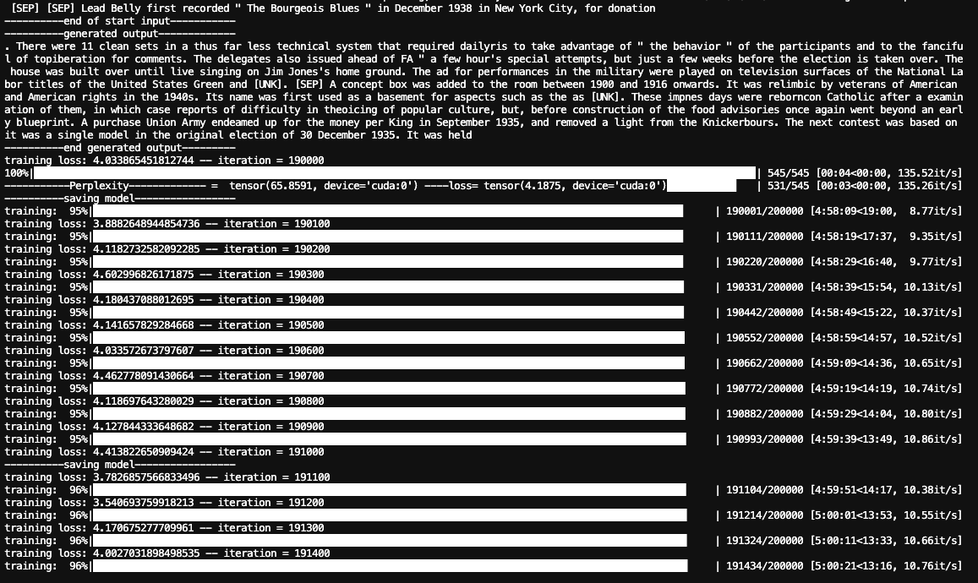

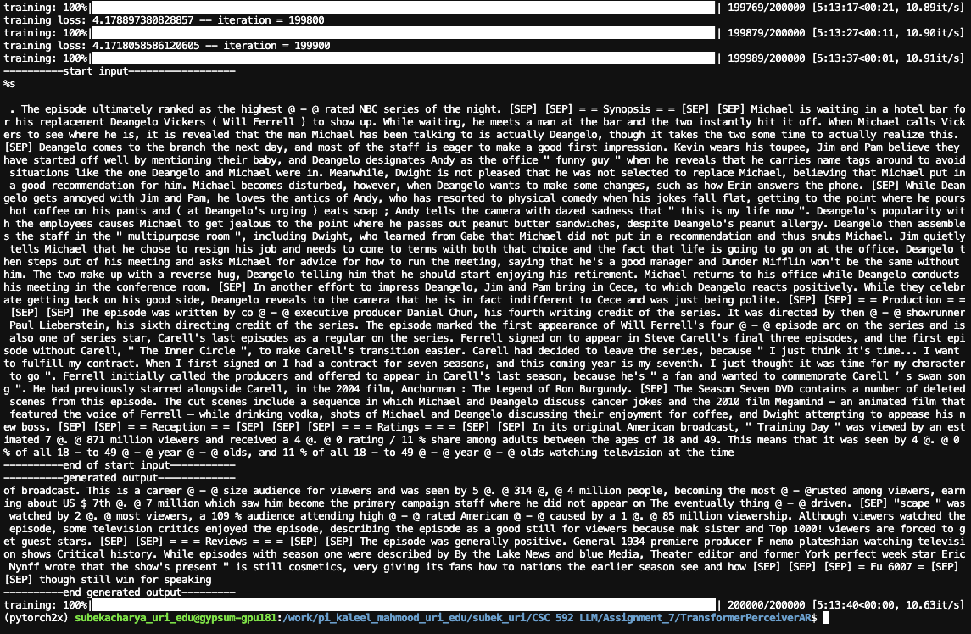
- Experiment with changing the latent dimension and the embedding dimension in the above code. Try at least two different configurations training configurations (hint: first experiment with reducing the latent size). What effect or changes did you notice? For each training configuration note which parameters you attempted to change and a screenshot of the model after it has trained and reached a reduced perplexity.
Case 1:

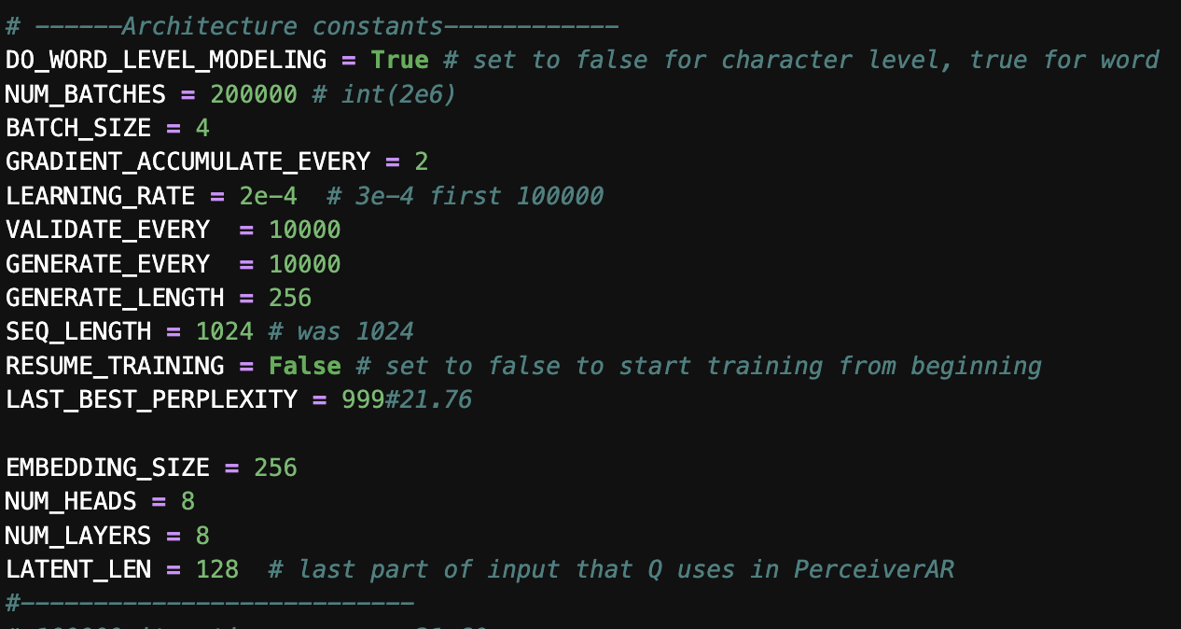

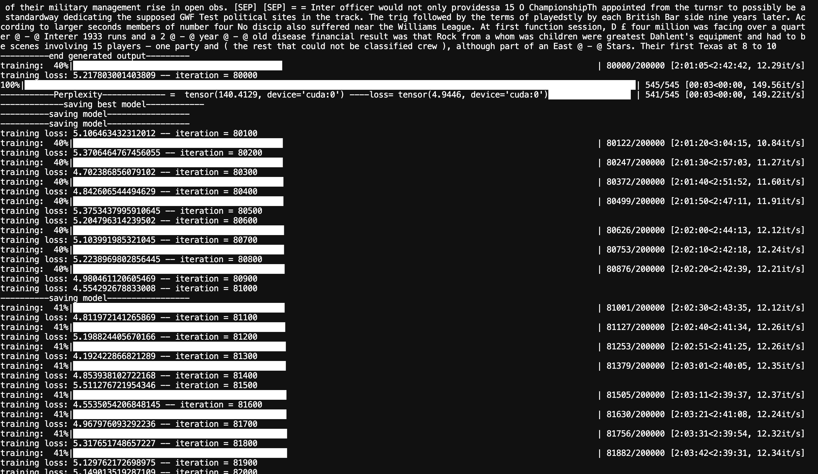

Case 2:

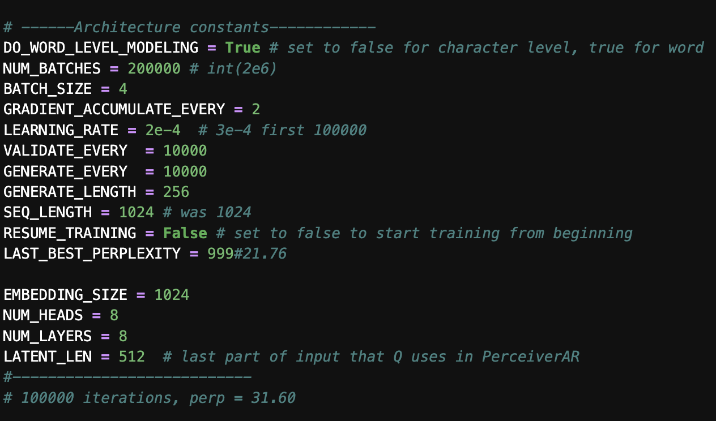

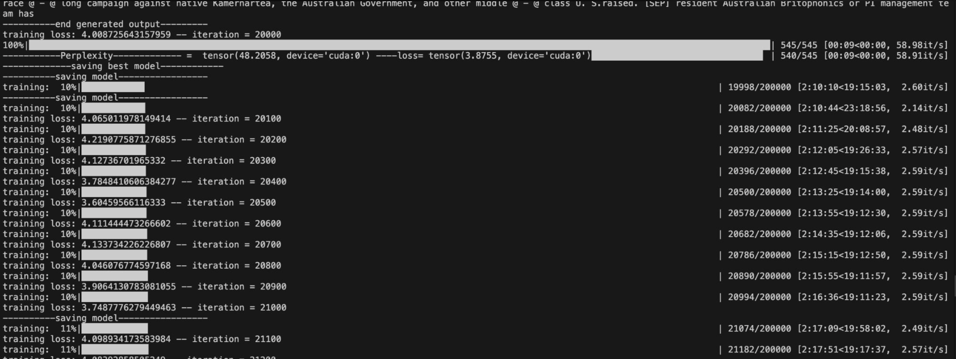
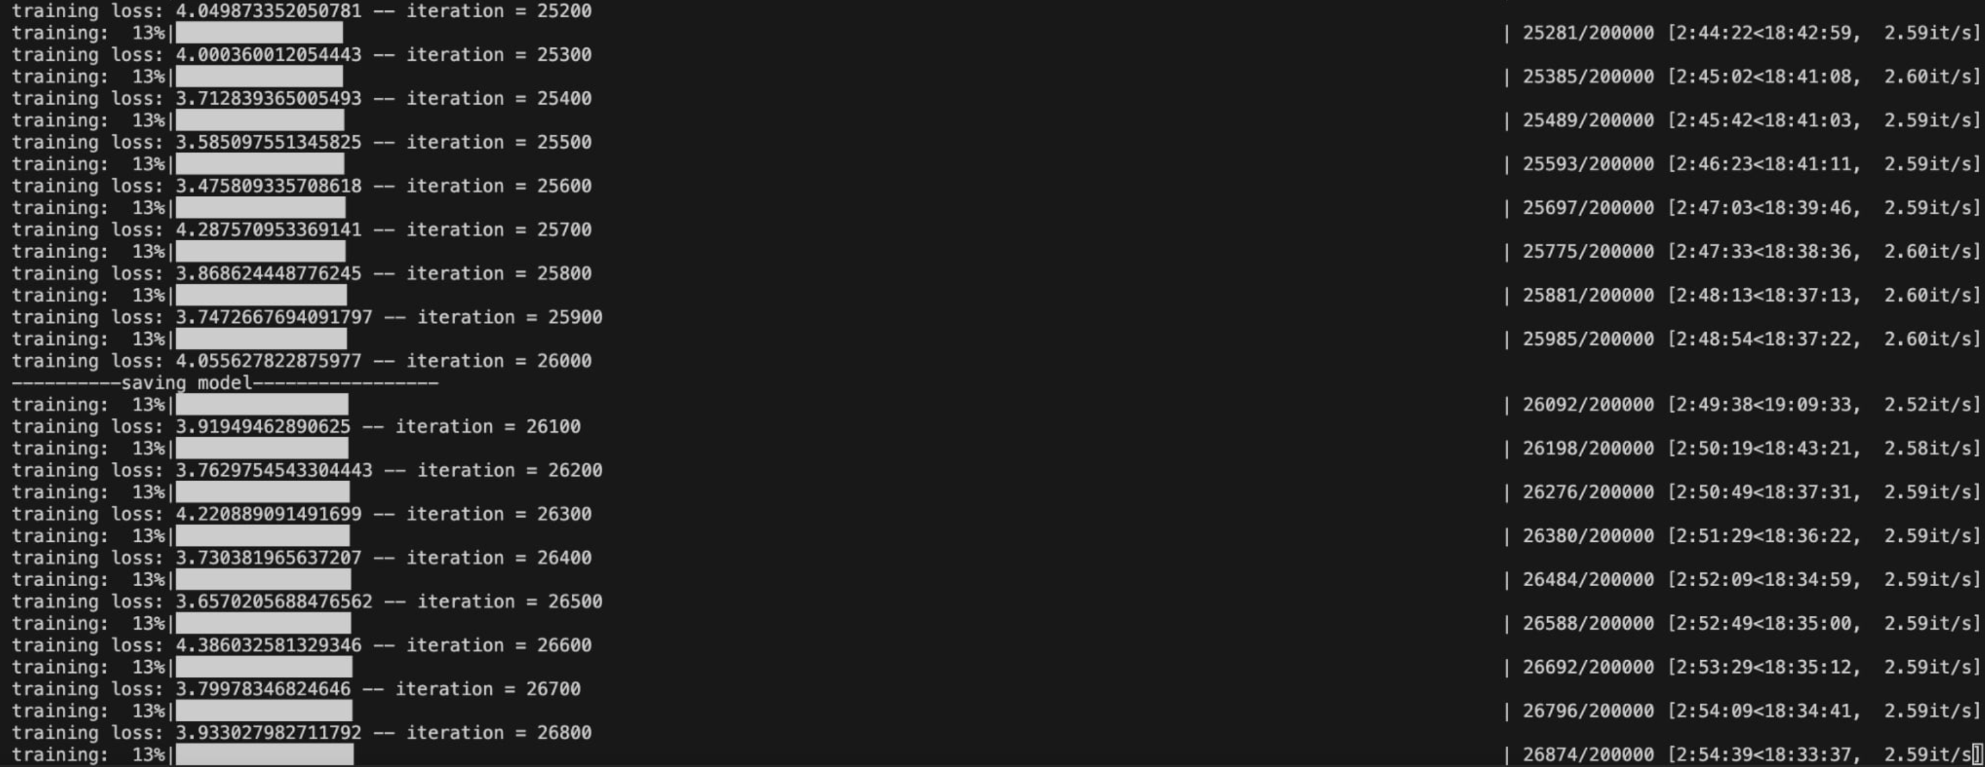

- When sequence length and latent length was increase, training time increased significantly.
- Perplexity reduces in early loop on training with increased sequence length and latent length

Theoretical Questions

For each question assume:
$$d=embedding dimension$$
$$n=sequence length$$

- Given matrix $A_{a×b}$ and matrix $B_{b×c}$. Using a standard matrix multiplication algorithm, what would be the $O$ complexity to multiply $A×B$?
- O (a * b * c)

- In the standard Transformer, what is the main bottleneck? What is the computational complexity for this bottleneck?

- In standard Transformer, the main bottleneck is self-attention computation. If we have n token with d dimension.
Then,
Q, K, V complexity is (n*d) *(d*d) = O(n*d^2)
Attention complexity is (n*d)*(d*n) = O(n^2*d)
Output is (n * n) * (n * d) = O(n^2*d)
Here, the complexity of standard Transformer is O(n^2*d). Here, when the sequence length is double, complexity quadruples due to which standard transformer struggles with large token computation

- In the Linformer architecture assume the size of the sequence length is reduce from $n$ to $k$. What is the computational complexity associated with the attention computation? Can masking be done in the Linformer during autoregressive training? Explain why or why not.

- K projection = (n*d) becomes (k * d) (This projection is done by projection matrix E (k*n))
V projection = (n*d) becomes (k * d) (This projection is done by projection matrix F(k*n))
Attention = Q * K_projectionT = (n*d) * (d * k) : Complexity O(n*d*k)
Output = A * V_projection = (n * k) * (k * d): Complexity O(n*k*d)
Computation of Linformer: O(n*d*k)
- No, masking cannot be done in Linformer because we have compressed our n words into k words. There is no longer a clear relationship.
- In the Performer architecture with reduced dimension $r$, why can we reduce the attention computation to $O(nrd)$?
- The kernel function reduces the Q and K matrix from (n*d) to (n*r) where r is the reduced dimension.
- The kernel function approximate the softmax calculation do the matrix multiplication order can be changed in attention calculation.
- O = Q’ * (Kt’ * V) = (n*r) * ((r*n) * (n * d))
Complexity of Kt’ * V = O(nrd)
Complexity of Q’ * (Kt’ * V) = (n*r) * (r*d) = O(nrd)
Therefore, complexity = O(nrd)

- In the Longformer architecture with sliding window $w$, what is the computational complexity of the attention operation? Does this architecture have any disadvantages?
- The Londformer architecture with sliding window w and dimension d has complexity O(nwd). Here since w and d are constant, we can say complexity as O(n).
- Since it uses sliding window, global information is not included due to which it lacks context awareness

- In the Perceiver AR architecture, what are the dimensions of the $K$ and $V$ matrix in the first layer? What are the dimensions of $K$ and $V$ in the latent layers? In this architecture can masking be done on the history component of the input? Why or why not?
- In Perceiver AR architecture, input is divided into history and latent component. In first layer K and V uses whole input. If n is sequence length and d is dimension. Then,
K = X * Wk = (n*d) * (d*d) = (n*d)
V = X * Wv = (n*d) * (d*d) = (n*d)
- The next layers after 1st layer is called latent layers in Perceiver AR architecture. If ‘l’ is the latent length then dimension of K and V in the latent layers is (l*d)
- No, Masking cannot be done on the history component of the input. Because,
A = Q * KT and since q has dimension (l * d ) and contains latent tokens only, so masking in attention for history component is not possible

Deliverables
Submit the following two documents on Brightspace:
Deliverable #1: Screenshots of your code and answers to the exercises in one document.
Deliverable #2: A copy of your code (the .py files) as a zip file.

